Application for the Seal of Quality
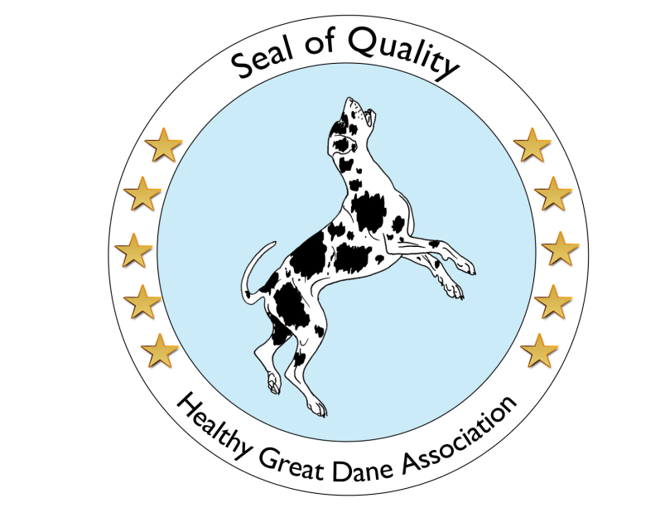
As a breeder, you can submit your application for the allocation of the Seal of Quality – Healthy Great Dane Association with the following form.
The decision on recognition or rejection will be made by the representatives of the Healthy Great Dane Association in writing within one month after detailed examination of the information provided by you. There is no legal right to recognition. In case of rejection, you will receive a detailed explanation.
In the case of a recognition you acquire the certificate “Healthy Great Dane Association” certified breeder as well as the associated quality seal in digital form. From now on, you may advertise your breeding with the title “Healthy Great Dane Association certified breeder” and the Seal of Quality: Healthy Great Dane Association. Further, you will receive all benefits of our association for certified breeders. In addition, a breeder portrait of you will be created by us on our website based on the information provided by you.
In the event of a breach of the self-commitment for certified breeders, the Association for Healthy Great Danes may issue a warning depending on the severity or revoke the certificate including the Seal of Quality. In the case of a withdrawal, you can no longer use the name
“Healthy Great Dane Association” certified breeder nor advertise any longer with the Seal of Quality: Healthy Great Dane Association. Furthermore, with the withdrawal all benefits for our certified breeders that go along with the certification expires and leads to the removal of all information of the breeder on our website.
Both the certification and its withdrawal will be published on our website.

(You have to answer questions marked with *)

What is your kennel name? *
What is your name? *
What is your email address? *
Your Address *
Your phone number:
Your mobile number:
Please enter your homepage, if available
Please enter your Facebook page, if available
Since when do you breed Great Danes? *
When was your last litter born with how many puppies? * Please add the pedigree and the HD X-ray and heart ultrasound reports of both parents (they will not be published)
How many litters with how many puppies have been born in your kennel so far? *
Have you ever had a double merle mating? If yes, when did you last? *
Have you ever made a mating with an COI over 6.25% (for 6 generations) and if so when last? *
Where are the puppies born and how do they grow up?
What do you do for socialization and imprinting the puppies? *
How many Great Danes do you currently own?(Please with full name and date of birth of the dogs) *
Do you own or breed other breeds of dogs? *
How are your dogs kept? *
How do you exercise your Great Danes mentally and physically? *
What do you do with young dogs that are not suitable for breeding and old breeding dogs who are retired? Will they stay with you or will they be given away? *
How important are exhibitions / championship titles to you? *
What is your opinion about inbreeding? *
What is your opinion about cropping? *
What do you think about double-merle matings? *
What is your opinion about color matings? *
How important is honesty and transparency in breeding for you? *
How do you assess the current situation of a Great Dane respective Health, Temperament and Standard? *
How would you like to improve health and life expectancy of the Great Dane with your breeding? *
How do you keep contact with your puppy buyers? *
What is your vision for the Great Dane in the future? What would be your wish? *

Please add 3 photos of you and your dogs and your kennel.
I hereby certify that I have truthfully answered the questions to the best of my knowledge and belief and allow the publication of this information and the photos provided by me on www.gesunde-dogge.de and www.healthy-dane.org.
I can contradict the publication at any time subsequently, after which the information will be removed from the aforementioned websites again.
I have read the Voluntary Self-Commitment (https://gesunde-dogge.de/voluntaryselfcommitment) and agree to it.
have read the privacy policy (https://gesunde-dogge.de/en/privacy-policy) and agree to it.

